

**MATERI**

**Kasih Sayang Allah**

Allah adalah Tuhan Kita.

Allah mempunyai 99 nama baik.

Nama-nama baik Allah disebut Asmaul Husna.

Diantaranya adalalah *ar-Rahman dan ar-Rahim!*

*Ar-Rahman* artinya Allah Maha Pengasih

*Ar-Rahim* artinya Allah Maha Penyayang

Kasih Allah diberikan kepada semua makhluk-Nya.

Kepada manusia, binatang, dan tumbuhan.

Bagi orang yang beriman akan mendapatkan sayang Allah.

Allah akan memasukkan orang yang beriman di surga.

**AYO KERJAKAN**



________________________________

________________________________

________________________________

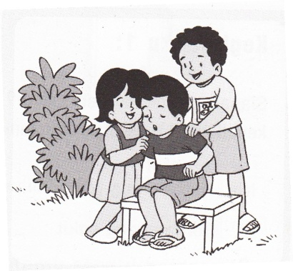

________________________________

________________________________

________________________________

________________________________



________________________________

________________________________

________________________________

________________________________

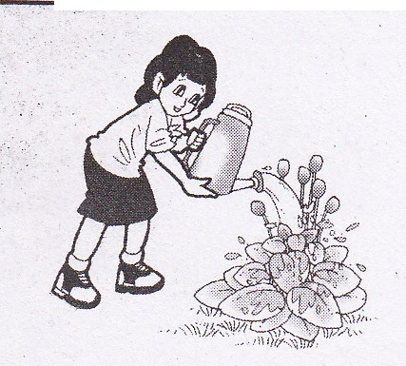

________________________________

________________________________

________________________________

________________________________



________________________________

________________________________

________________________________

________________________________

**AKU BISA**

1. Berilah tanda centang (V) pa kolom “ya” atau “tidak”!

|  |  |  |  |
| --- | --- | --- | --- |
| **No.** | **Uraian** | **Ya** | **Tidak** |
| 1. | Aku bisa menyebutkan arti *ar-Rahman* |  |  |
| 2. | Aku bisa menyebutkan arti *ar-Rahim* |  |  |
| 3. | Aku menyayangi diriku |  |  |
| 4. | Aku menyayangi orang tuaku |  |  |
| 5. | Aku menyayangi saudaraku |  |  |
| 6. | Aku menyayangi teman-temanku |  |  |
| 7. | Aku menyayangi tumbuhan |  |  |
| 8. | Aku menyayangi hewan piaraanku |  |  |
| 9. | Aku menyangi guruku |  |  |
| 10. | Aku menyayangi semua makhluk Allah |  |  |

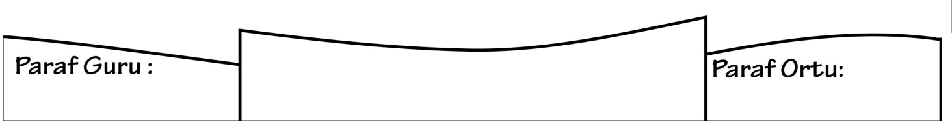

Nilai :