

Lembar Kegiatan Siswa

Kelas: I Semester I

www.sdsabilillah.sch.id

**Nama : ______________________ Kelas: _________ Tanggal : ____________________**

No:



Lembar Kegiatan Siswa

Kelas: I Semester I

www.sdsabilillah.sch.id

**Nama : ______________________ Kelas: _________ Tanggal : ____________________**

No:





**MATERI**

**Kasih Sayang Allah**

Allah adalah Tuhan Kita.

Allah mempunyai 99 nama baik.

Nama-nama baik Allah disebut Asmaul Husna.

Diantaranya adalalah *ar-Rahman dan ar-Rahim!*

*Ar-Rahman* artinya Allah Maha Pengasih

*Ar-Rahim* artinya Allah Maha Penyayang

Kasih Allah diberikan kepada semua makhluk-Nya.

Kepada manusia, binatang, dan tumbuhan.

Bagi orang yang beriman akan mendapatkan sayang Allah.

Allah akan memasukkan orang yang beriman di surga.

**AYO KERJAKAN**

1. Ceritakan gambar kasih sayang di bawah ini!



______________________________

________________________________

________________________________



________________________________

________________________________

________________________________

________________________________

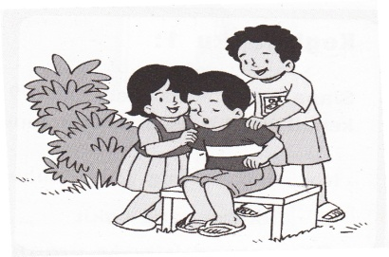

________________________________

________________________________

________________________________

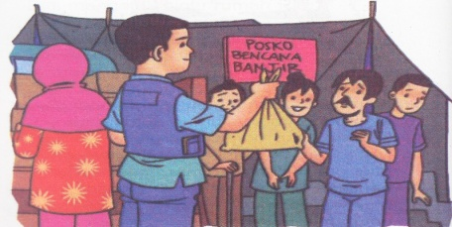 ________________________________

________________________________

________________________________

________________________________

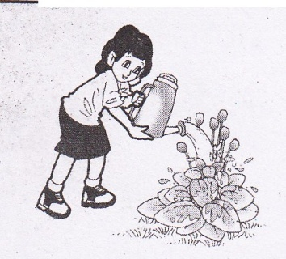

________________________________

________________________________

________________________________

________________________________

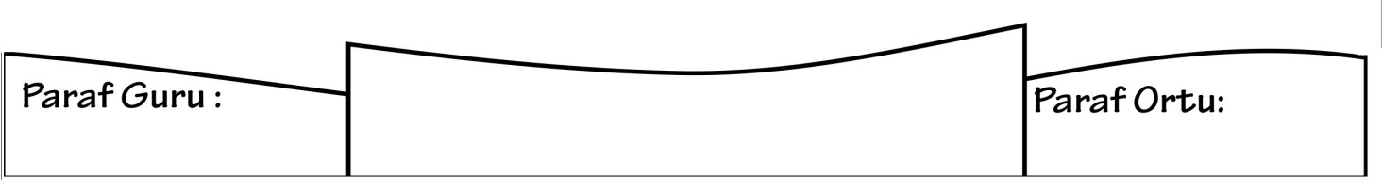

Nilai :