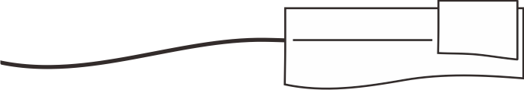

Lembar Kegiatan Siswa

Kelas: I Semester I

www.sdsabilillah.sch.id

**Nama : ______________________ Kelas: _________ Tanggal : ____________________**

No:



**Allah Maha Raja yang berkuasa menciptakan dan menjadikan alam menjadi indah.**

**Coba ceritakan secara singkat indahnya alam pada vidio yang kamu lihat?**

**...............................................................................................................................................................**

**...............................................................................................................................................................**

**...............................................................................................................................................................**

**...............................................................................................................................................................**

**...............................................................................................................................................................**

**...............................................................................................................................................................**

**...............................................................................................................................................................**

**...............................................................................................................................................................**

**...............................................................................................................................................................**

**...............................................................................................................................................................**

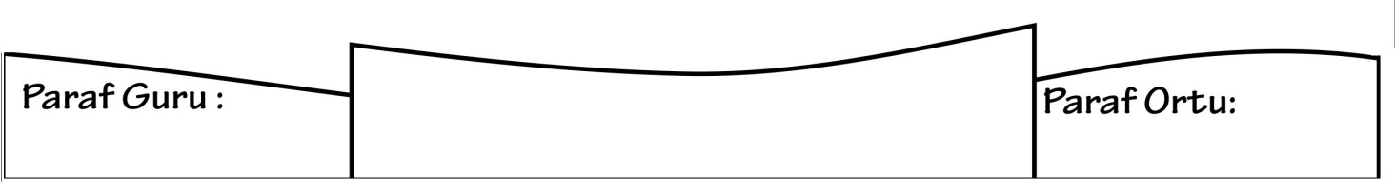

Nilai :